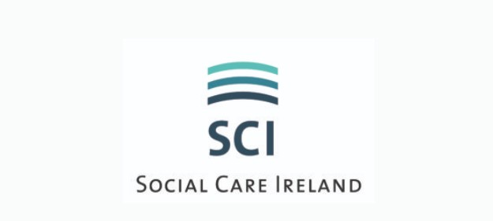
ADVERTISE WITH US

Please fill out the below form and send (word document format) to info@socialcareireland.ie

Please note: The qualification criteria (outlined in the job spec/description) must be in line with Social Care Ireland’s recruitment eligibility criteria as outlined below;
Essential Statutory Qualifications & Experience:
Eligible applicants will be those who on the closing date for the competition:
- Possess the National Diploma in Childcare awarded by Quality & Qualifications Ireland(QQI) (Dearbhu Cáiliochta agus Cáiliochtai Éireann) (formerly HETAC)/DIT or
- Possess the National Diploma in Applied Social Care Studies awarded by Quality & Qualifications Ireland, (QQI) (Dearbhu Cáiliochta agus Cáiliochtai Éireann)/DIT or
- Possess the Diploma in Social Care awarded by awarded by Quality & Qualifications Ireland, (QQI) (Dearbhu Cáiliochta agus Cáiliochtai Éireann) (formerly HETAC)//DIT or
- Possess the Diploma in Applied Social Studies/Social Care from DIT or
- Possess a BA (Ord) in Social Care Practice (Level 7 on the QQI framework)
- Possess Open Training College National Diploma in Applied Social Studies (Disability). or
- Possess an equivalent qualification

>>>>>>>>>>>>>>>>>>>>>>>>>>>>>>>>>>>>>>>>>>>>>>>>>>>>>>>>>>>>>>>>>>>>>>

Please complete Employers Application Form below
Send completed form to info@socialcareirland.ie

>>>>>>>>>>>>>>>>>>>>>>>>>>>>>>>>>>>>>>>>>>>>>>>>>>>>>>>>>>>>>>>>>>>>>>

Employers Details

Company/Organisation Name:
Contact Person:
Phone:
Email:
Company logo:

Job Details

Job Title:
Job Location:
Responsibilities include:
Criteria:
- Essential:
- Desirable:
Salary:
Benefits:
Any Other Information:
*Closing Date:
*How to Apply/Contact Details:
Attachments: Yes/No
(Please include a maximum of two additional documents that can be made available as downloads from your advert (flyers, forms, job specifications, etc.)

>>>>>>>>>>>>>>>>>>>>>>>>>>>>>>>>>>>>>>>>>>>>>>>>>>>>>>>>>>>>>>>>>>>>>>

