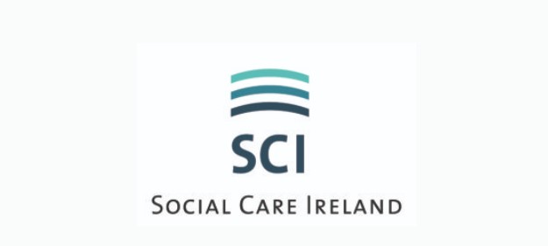
ADVERTISE WITH US

Advertise with Social Care Ireland today and reach thousands of social care workers weekly!
Advertising your job post with social care Ireland enable you to access qualified social care workers and those working in similar roles in an easy and affordable way.
We help you reach job seekers through:
- Job promotion via our social media platforms, twice weekly (2,000+per week)
- Email Social Care Ireland members directly
- Adverts will be individually placed in the 'Jobs' section of our website socialcareireland.ie
- Curam Magazine is published three times a year, if the publication of the magazine coincides with your advertisement, the advert will be published free of charge.

Terms & Conditions:
- Payment must be received prior to advertisement being placed.
- Advertisement will be posted within 3 working days of receipt of payment
- Advertisements will be removed from the website after the closing date for applications or after a 3-month period.

Advertisement Free (3-month period)
- €150 (commercial organisations)
- €100 (charity organisations)
Adverts should be submitted by email to our Office Administrator info@socialcareireland.ie - include the following items:
- Relevant Social Care Ireland Job Template (see below).
- Any documents that you wish to have attached to your advert (as downloadable files).
- Payment receipt/payment reference number.
- The qualification criteria (outlined in the job spec/description) must be in line with Social Care Ireland’s requitement eligibility criteria as outlined below

Essential Statutory Qualifications & Experience:
Eligible applicants will be those who on the closing date for the competition:
- Possess the National Diploma in Childcare awarded by Quality & Qualifications Ireland(QQI) (Dearbhu Cáiliochta agus Cáiliochtai Éireann) (formerly HETAC)/DIT or
- Possess the National Diploma in Applied Social Care Studies awarded by Quality & Qualifications Ireland, (QQI) (Dearbhu Cáiliochta agus Cáiliochtai Éireann)/DIT or
- Possess the Diploma in Social Care awarded by awarded by Quality & Qualifications Ireland, (QQI) (Dearbhu Cáiliochta agus Cáiliochtai Éireann) (formerly HETAC)//DIT or
- Possess the Diploma in Applied Social Studies/Social Care from DIT or
- Possess a BA (Ord) in Social Care Practice (Level 7 on the QQI framework)
- Possess Open Training College National Diploma in Applied Social Studies (Disability). or
- Possess an equivalent qualification

>>>>>>>>>>>>>>>>>>>>>>>>>>>>>>>>>>>>>>>>>>>>>

Please complete Employers Application Form below
Send completed form to info@socialcareirland.ie

Employers Details

Company/Organisation Name:
Contact Person:
Phone:
Email:
Company logo:

Job Details

Job Title:
Job Location:
Responsibilities include:
Criteria:
- Essential:
- Desirable:
Salary:
Benefits:
Any Other Information:
*Closing Date:
*How to Apply/Contact Details:
Attachments: Yes/No
(Please include a maximum of two additional documents that can be made available as downloads from your advert (flyers, forms, job specifications, etc.)

>>>>>>>>>>>>>>>>>>>>>>>>>>>>>>>>>>>>>>>>>>>>>>>>>>>

